Chapter 5, Problem 30

In the circuit shown in Fig. 5.68, find i_{x} and the power absorbed by the 20-kΩ resistor.

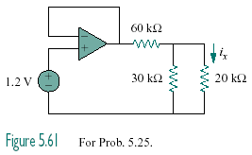

Figure 5.68
For Prob. 5.30.

